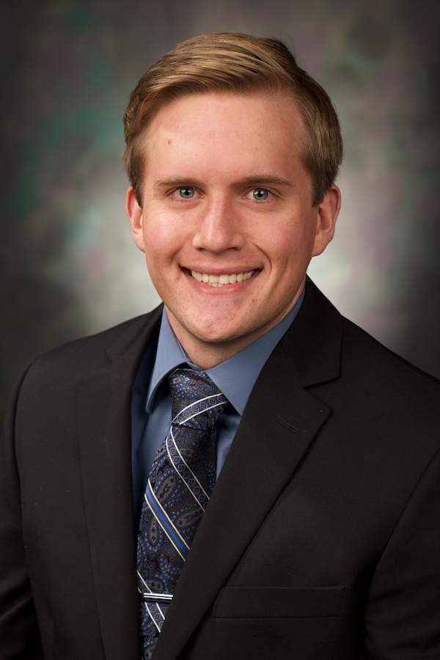Curriculum Vitae

**Contact information**

Jake Johnson

906 Lewis St. Vermillion, SD 57069

Phone: 605-351-2194

E-mail: jake.n.johnson@coyotes.usd.edu

**Academic Background**

Sanford School of Medicine, University of South Dakota 2015-present Doctor of Medicine candidate, expected graduation 2019

University of South Dakota; Vermillion, SD 2014-2015

Post-baccalaureate course work

Avera School of EMS; Sioux Falls, SD 2014

EMT training program and certification Basic

University of South Dakota; Vermillion 2014  
 Bachelor of Science: Biology major with minor in Chemistry, *Summa Cum Laude*

**Academic Honors and Awards**

AOA Honor Society, Inductee 2018

Coyote Clinic Recipient of the Class of 2019 volunteerism award 2018

Judson O. Mabee Scholarship 2018-2019

Dr. Duane Reaney Family Scholarship 2018-2019

Dr. Charley F. & Elizabeth R. Gutch Scholarship 2018-2019

Faithe Family Scholarship 2017-2018

Avera Sacred Heart Health Foundation Scholarship 2017-2018

Sanford School of Medicine Scholarship 2016-2017

Faithe Family Scholarship 2016-2017

Dr. Roy S. & Clara E. Hubbs Memorial Scholarship 2015-2016

William Edwin & Anna H. Wallar Scholarship 2015-2016

**Research Experiences**

**1. Scholarship Pathways Project (SPP)** 11/17-Current

Sanford School of Medicine/Sanford Health Sioux Falls, SD

“Assessing the effectiveness of RTS testing in identifying patients at risk for anterior cruciate ligament graft failure”.

Location: Sanford Sports Science Institute

Mentor: Lisa MacFadden, PhD

Role: Primary Investigator

**2. Medical Student Research Project (MSRP)** 05/2015-07/2015

Sanford School of Medicine Vermillion, SD

“*Enterococcus faecalis:* Endogenous Toxin/Antitoxin (TA) Systems and their Function”.

Location: USD Basic Biomedical Sciences

Role: Research Technician

Mentor: Keith Weaver, PhD

**3. Research Technician**  05/2013-08/2014  
University of South Dakota Vermillion, SD

“Myostatin Expression and the Regulation of Muscle and Heart Size in Migratory Passerine Birds”.

Location: USD Biology Department

Mentor: David Swanson, PhD

**4. Research Technician**  05/2012-08/2012  
University of South Dakota Vermillion, SD  
Location: USD Biology Department

Mentor: Kaius Helenurm, PhD

**Publications**

**1.** Weaver KE, Chen Y, Miiller EM, et al. Examination of Enterococcus faecalis Toxin-Antitoxin System Toxin Fst Function Utilizing a Pheromone-Inducible Expression Vector with Tight Repression and Broad Dynamic Range. *J Bacteriol.* 2017;199(12)

**2.** King MO, Zhang Y, Carter T, Johnson J, Harmon E, Swanson DL. Phenotypic flexibility of skeletal muscle and heart masses and expression of myostatin and tolloid-like proteinases in migrating passerine birds. *J Comp Physiol B.* 2015;185(3):333-342.

**Presentations and Abstracts**

**1. Alpha Omega Alpha/Scholarship Pathways Program Research Symposium** 5/2018

Location: Sanford School of Medicine/Sanford Health Sioux Falls, SD

Abstract and Poster title: “Assessing the effectiveness of RTS testing in identifying patients at risk for anterior cruciate ligament graft failure ”.

Authors: Jake Johnson MSIII, Jennifer Dalland MS ATC, Lisa MacFadden PhD

Presented poster to local area physicians and medical student colleagues

**2. Health Quality Improvement Project (HQIP) Presentation** 11/2017

Location: Indian Health Services and Yankton SSOM campus Wagner, SD

Abstract and Presentation title: “Education on Substance Abuse in Pregnancy for an Underserved Population”

Authors: Jake Johnson MSIII, Nick Purcell MSIII, TiAnna Voigt MSIII, Luke Lansman MSIII, Eric Habbe MSIII

Presented to expecting mothers at Indian Helath Services Hospital in Wagner, SD about the side effects of alcohol and illicit drug use in pregnancy. Also provided a pamphlet to expecting mothers covering information presented at event.

**3. Cultural Immersion Project Presentation** 9/2017

Location: Health Services Center Yankton, SD

Presentation title: The Social Aspect of Aging: Sanford Vermillion Care Center

Authors: Jake Johnson MSIII and Mark Larson MSIII

Presented to SSOM faculty on experience volunteering at Sanford Vermillion Care Nursing Home and Assisted Living Center

**4. Medical Student Research Project (MSRP) Forum** 05/2015-07/2015

Location: Sanford School of Medicine, Basic Biomedical Sciences Vermillion, SD

Abstract and Presentation title: “*Enterococcus faecalis:* Endogenous Toxin/Antitoxin (TA) Systems and their Function”.

Authors: Jake Johnson MSII, Elly Miller, Keith Weaver PhD

Presented research at the medical student research forum to medical student colleagues and USD Basic Biomedical Science Faculty members

**5.University of South Dakota Idea Fest** 04/2014

Location: University of South Dakota Vermillion, SD

Abstract and Presentation title: “Myostatin Expression and the Regulation of Muscle and Heart Size in Migratory Passerine Birds”.

Authors: Jake Johnson, Yufeng Zhan, David Swanson PhD

Presented research at Ideafest, an annual event to showcase undergraduate participation in research, to USD Biology Department Faculty and undergraduate student colleagues

**Volunteering, Community Service, & activities**

**1. Servant’s Heart Clinic** 2017-Current Yankton, SD

Primary responsibility was to aid in diagnosis and treatment patients who visited the free clinic in Yankton, SD.

**2. LCME Accreditation Student Panel Member** 09/2017

**3. Bike Helmet Sizing** 04/5/2017  
Yankton High School Yankton, SD

Sized bike helmets for Yankton Elementary students and provided information regarding bike safety

**4. AHEC Medical Student Volunteer** 03/9/2017

Yankton High School Yankton, SD

Presented to Yankton High School seniors on life as a medical student and methods to prepare for applying to medical school

**5. Healer’s Art Elective** Fall 2016

Sanford School of Medicine Vermillion, SD

Participated in National Curriculum discussing thoughts and emotions surrounding the end of life

**6. Coyote Clinic**  2015-2016  
Avera Health Sioux Falls, SD  
Student run, physician-guided clinic. Collected History of present illness and generated a differential diagnosis for review by attending physicians

**7. Welcome Table** 2016  
First United Methodist Church Vermillion, SD  
Recorded blood pressure and glucose readings for any individual at the welcome table who desired to have them measured

**8. Inpatient Rehabilitation Unit**  2011-2012  
Sanford Health Sioux Falls, SD  
interacted with patients within the unit and ensured their comfort. Valued understanding the importance of patient communication and patients’ well-being for optimal patient outcomes

**Teaching and leadership Experience**

**1. Medical School Supplemental Instruction** 2018  
University of South Dakota Sanford School of Medicine Yankton, SD

Generated a presentation and gave an oral lecture to the Yankton Campus third year medical students titled: “Diabetes Mellitus: presentation, complications, and long term medical management.”

**2. SSOM Yankton Campus Student Representative** 2017-Current  
University of South Dakota Sanford School of Medicine Yankton, SD

Presented Yankton Campus student concerns regarding curriculum to SSOM administration in an effort to improve student experience and overall well-being

**3. Biochemistry Tutoring (BIOC-430)**  01/2015-05/2015  
University of South Dakota Vermillion, SD

Tutored and attended BIOC-430 lectures instructed by Dr. Pasquale Manzerra. Assisted multiple students in learning course material and helped Dr. Manzerra in preparing quiz/course material questions throughout the semester

**4. Tutor/Supplemental Instruction** 08/2012-05/2014  
University of South Dakota Vermillion, SD  
Tutored in the fall of 2012 as the Supplemental Instruction leader for Biology 151. Held two to three study large group sessions per week in order to review lecture material and administer a nightly quiz. Switched exclusively to one-on-one tutoring in the spring of 2013

**Professional Experience**

**1. Sanford Behind the Scenes** 06/2016  
Sanford Health Sioux Falls, SD

Took part in a two-week shadowing experience to understand the daily life of physicians in different specialties. Shadowed various specialties including: Pathology, Orthopedics, and Family Medicine.

**2. EMT Certification Course** 05/2014-07/2014  
Avera School of EMS Sioux Falls, SD

Participated in an eight-week EMT course. Gained understanding of basic healthcare skills such as vital monitoring, patient assessment, and the presentation of common illnesses. Received an “A” in the course and passed the National Registry exam.

**3. Physician Shadowing** 05/2011-06/2014

Sanford Health Sioux falls Sioux Falls, SD

Followed physicians during this time period in order to enhance my health care exposure.

**Professional licenses/certifications**

ACLS Certification 2017

BLS Certification 2016

EMT-BASIC Certification 2014

**Affiliations/Memberships**

AOA Honor Society Student member

AMA-Student member

SDSMA-Student member

**Interests and Hobbies**

I enjoy participating in sports such as golf and basketball along with following college basketball, professional basketball, professional football, and the PGA tour. I also enjoy spending time reading, lifting weights, and bird watching.